2ndISTCSD 2018

16-17 November 2018 I Hotel Pondok Tingal Borobudur, Magelang, Central Java
2nd INTERNATIONAL CONFERENCE
ON SOCIAL TRANSFORMATION, COMMUNITY
AND SUSTAINABLE DEVELOPMENT 2018

“The Role of Local Government to Community and Sustainable Development”

REGISTRATION FORM
(Please tick “/”) COMPULSORY
3rd Borobudur Conference on Public Administration
3rd International Conference on Tourism Role in Sustainable Community Development
4th Conference on Social Transformation
3rd International Social Sciences Tourism Research Conference
DATE:
Country:
Designation:
Paper titel :
Surname:
First Name:
Nationality:
University/Organization:
Full Address:
Telephone: | Fax:
Email:
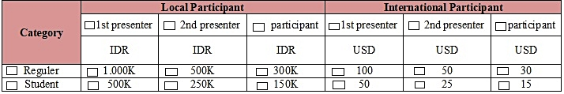
Please tick (“/”) compulsory

